**How to deploy and run Birt Demo application**

**Preparing**

**Precondition:** be sure you have installed maven, Tomcat 6, actuate server (for actuate based reports only)

1. Download demo archive from <https://subversion.exadel.com/exadel/jsf4birt/concord/trunk/modules/samples/samples.rar>
2. Unzip archive
3. Change actuate settings in web.xml file (/samples/birt-demo/src/main/webapp/web-ing/web.xml). Define URL to actuate server, login and password:

<!-- Birt settings -->

<context-param>

<param-name>actuate.serverUrl</param-name>

<param-value>http://localhost:8900/iportal</param-value>

</context-param>

<context-param>

<param-name>actuate.serverLogin</param-name>

<param-value>administrator</param-value>

</context-param>

<context-param>

<param-name>actuate.serverPassword</param-name>

<param-value></param-value>

</context-param>

**Deploying under Eclipse**

1. Go to /samples path
2. Execute maven command: mvn eclipse:eclipse –Dwtpversion=1.5
3. Import generated project to eclipse workspace.

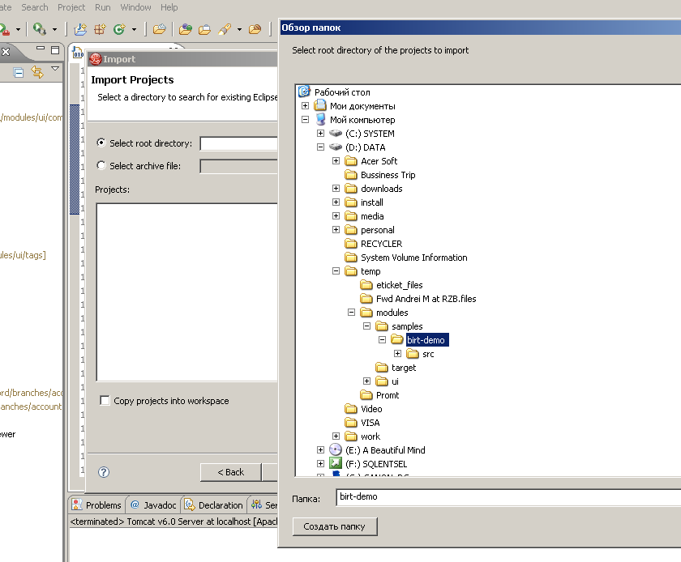

1. Add birt-demo application to Tomcat 6 deployments

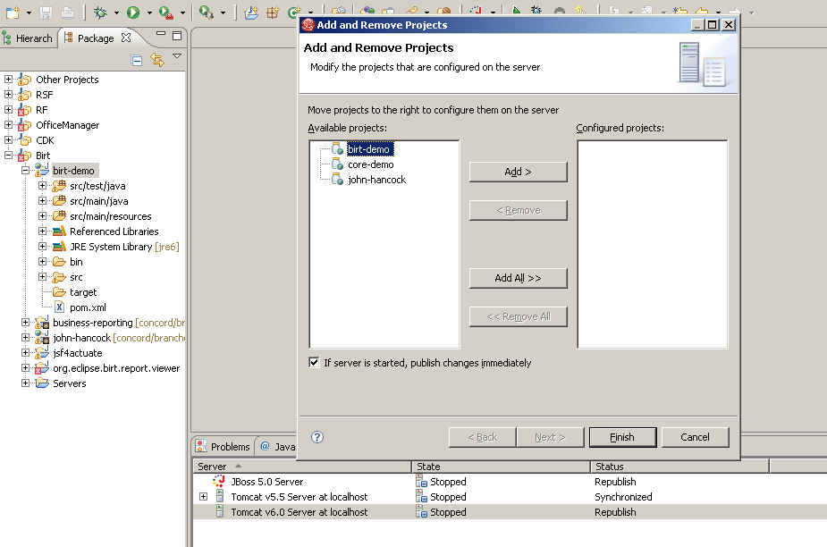

1. Run server

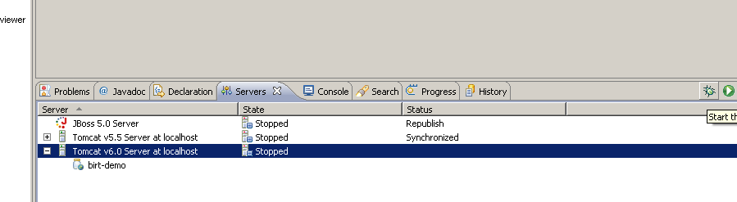

1. Go to <http://localhost:8080/birt-demo>

**Deploying without IDE**

1. Go to /samples path
2. Execute maven command: mvn clean install
3. Go to /birt-demo path
4. Copy built file /target/birt-demo.war to Tomcat 6 deploy folder
5. Run server
6. Go to <http://localhost:8080/birt-demo>